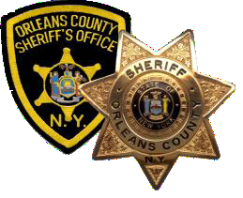  Christopher M. Bourke  SHERIFF  www.orleansny.com/sheriff | COUNTY OF ORLEANS  Office of the Sheriff  400 Public Safety Bldg.,  13925 State Route 31  Albion, New York 14411-9386 | Michael C. Mele  Undersheriff  Jeffrey A. Gifaldi  Chief Deputy  Scott D. Wilson  Jail Superintendent
Communications – (585) 589-5527
Fax – (585) 589-6761
Administrative Offices – (585) 590-4142
Fax – (585) 590-4178
County Jail – (585) 589-4310
Fax – (585) 589-2522

On June 12, 2020, Governor Andrew Cuomo issued Executive Order No. 203 requiring each local government in New York State to adopt a policing reform plan by April 1, 2021. The Order authorizes the Director of the Division of the Budget to condition State aid to localities on the adoption of such a plan.

The New York State Police Reform and Reinvention Collaborative asks all local police agencies to actively engage with stakeholders in the local community and have locally-approved plans for the strategies, policies and procedures of local police agencies. The plan must include the appropriate role of the police, but allow the police to do their jobs to protect the public. The Orleans County Sheriff’s Office has put together a committee to help draft the plan.

Now, we are asking for public comment so that we can learn from the community as we review the current perspective of their relationship with the Orleans County Sheriff’s Office. The public comment period is open until February 10, 2021. The comments will assist the Sheriff’s Office and the committee with drafting their plan. Please either comment by using the online form or mail in your comments to:
Orleans County Sheriff’s Office
13925 State Route 31
Albion NY 14411

